**“IMRB”**

**SVN location for CHD**

**Course Path [FTP] \***

Running Link:

[http://ftp2.gc-solutions.net/ftp/santoshm/IMRB/Weighting and Projection Fundamentals/story.html](http://ftp2.gc-solutions.net/ftp/santoshm/IMRB/Weighting%20and%20Projection%20Fundamentals/story.html)

Downloadable Link:

[http://ftp2.gc-solutions.net/ftp/santoshm/IMRB/Weighting and Projection Fundamentals.zip](http://ftp2.gc-solutions.net/ftp/santoshm/IMRB/Weighting%20and%20Projection%20Fundamentals.zip)

**Feedback sheet [SVN] \***

[http://192.168.2.4/content2016/IMRB/03_Project_Development/Construction/QC_Reports/External/Gold/IMRB_2 June.docx](http://192.168.2.4/content2016/IMRB/03_Project_Development/Construction/QC_Reports/External/Gold/IMRB_2%20June.docx)

**SB [SVN] \***

[http://192.168.2.4/content2016/IMRB/03_Project_Development/Construction/ID/Storyboards/IMRB_Weighting and Projection Fundamentals_SB.pptx](http://192.168.2.4/content2016/IMRB/03_Project_Development/Construction/ID/Storyboards/IMRB_Weighting%20and%20Projection%20Fundamentals_SB.pptx)

**Release notes:**

1. Scope of validation is **feedback sheet** only.
2. As per the client he is not able to move forward after he visit “**One variable**” section in the screen shown below in screenshot.
3. Please note menu is forced.
4. Please check from both the links **running** and **downloadable** link.
5. It has to be closed by 3 PM today, because we have call at 4 PM with client today.

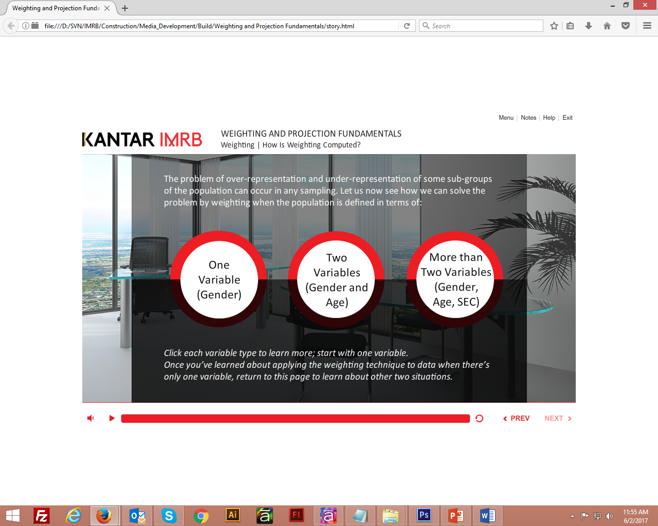

## Regards,

## Neeraj Chauhan

## Sr. Graphic Designer | G-Cube Solutions

## cid:image035.png@01D290F0.0872AE90[neerajc@gc-solutions.net](mailto:neerajc@gc-solutions.net)

## cid:image036.png@01D290F0.0872AE90neerajc-gc

## cid:image037.png@01D290F0.0872AE90+91.120.4000.318 cid:image038.png@01D290F0.0872AE90 7838079287

## cid:image039.png@01D290F0.0872AE90